SQL-DBMS-IPL-CASE-STUDY

- PROBLEM STATEMENT
Pie-in-the-Sky, is a mobile app that is used for bidding for IPL matches legally. Any registered user can bid for any of the IPL matches listed in it. New users or the bidders need to register themselves into the app by providing their mobile phone number, email id and a password. Admin will maintain the match roster and keep updating other details in the system. The app shows the match details which includes the playing team, the venue of the match and current standing of the teams on the points table. It will display the winner at the end of the match and update the team standings in the tournament and bidder points table. System will send updates to the bidders whenever required. It will also generate the bidders' leader board.

A bidder can do following things using this app:
- can see all the match schedules (teams, date & time of the match, location).
- bid on a team for a match before the start of the match
- can predict the match winner only till its toss occurs (Note that match start time might change due to weather conditions)
- can bid for any number of matches
- after bidding on a team, (s)he would be able to change his/her team before the match starts
- bidding cannot be changed once the respective match starts
- can cancel the bid on a match; will not lose any points
- at any time, bidder will be able to see his/her points and his/her position in the overall bidder standings.
- can see top 3 leader positions
- can see team standings anytime (i.e. their points tally)
- cannot see any details of other bidders

Admin can do following activities:
- manage tournament (tournament id, duration, description)
- manage teams (description of players and team)
- schedule and reschedule matches. Each team will play only once with remaining teams
- edit details of match and stadium
- update match statistics (date and match result of all the earlier matches)
- declare the result of the match along with their scores
- declare winner and loser along with their points
- update team statistics (team and player performance)
- update overview at the end of the match
- view all the bidders bidding on a particular team and the %age of users supporting a team

- METHODOLOGY:

- Create these tables in the database by running the database script provided

- The script also has statements to insert appropriate data into all these tables

- Test the successful execution of the script by selecting some rows from few tables

- Clearly understand the structure of each table and relationships among them

- Insert / update appropriate rows into relevant tables if you need to get more rows in the output to verify your answers

- ACTIONS TO BE PERFORMED ON OUR SQL IPL CRICKET DATABASE –
- SQL query to Show the percentage of wins of each bidder in the order of highest to lowest percentage.

- SQL query to Display the number of matches conducted at each stadium with stadium name, city from the database.

- SQL query to displaythe percentage of wins by a team which has won the toss in a given stadium.

- SQL query to Show the total bids along with bid team and team name.

- SQL query to Show the team id who won the match as per the win details.

- SQL query to Display total matches played, total matches won and total matches lost by team along with its team name.

- SQL query to Display the bowlers for Mumbai Indians team.

- SQL query to display the number of all-rounders are there in each team, Display the teams with more than 4 all-rounder in descending order.

- ER Diagram

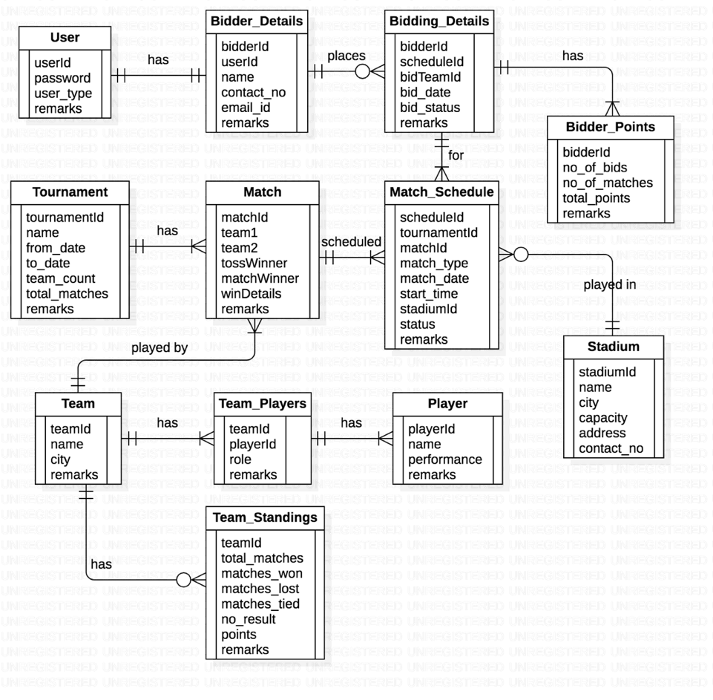

- LIST OF TABLES

- Table: IPL_User

Column name | Data type | Comments
UserId | VARCHAR | Primary key
Password | VARCHAR | Not null, encrypted format
User_type | VARCHAR | Admin or Bidder. Not null
Remarks | VARCHAR

- Table: IPL_Stadium

Column name | Data type | Comments
StadiumId | NUMBER | Primary key
Stadium_name | VARCHAR | Unique, Not null
City | VARCHAR
Capacity | NUMBER
Address | VARCHAR
Contact_no | NUMBER

- Table: IPL_Team

Column name | Data type | Comments
TeamId | NUMBER | Primary key
Team_name | VARCHAR | Unique, Not null
Team_city | VARCHAR | Origin city of the team
Remarks | VARCHAR

- Table: IPL_Player

Column name | Data type | Comments
PlayerId | NUMBER | Primary key
Player_name | VARCHAR | Unique, Not null
Performance | VARCHAR | Performance details
Remarks | VARCHAR

- Table: IPL_Team_players

Column name | Data type | Comments
TeamId | NUMBER | Composite Primary key
PlayerId | NUMBER | Composite Primary key
Player_role | VARCHAR | Captain, Batsman, Bowler, WK, etc.
Remarks | VARCHAR

- Table: IPL_Tournament

Column name | Data type | Comments
TournamentId | NUMBER | Primary key
Tournament_name | VARCHAR | Not null
From_date | DATE
To_date | DATE
Team_count | NUMBER
Total_matches | NUMBER
Remarks | VARCHAR

- Table: IPL_Match

Column name | Data type | Comments
MatchId | NUMBER | Primary key
TeamId1 | NUMBER | FK from Team table. Not null
TeamId2 | NUMBER | FK from Team table. Not null
TossWinner | NUMBER | Team no. 1 or 2
MatchWinner | NUMBER | Team no. 1 or 2
WinDetails | VARCHAR | Team 1 or 2 Won by XX runs or X wickets, Match tied.
Remarks | VARCHAR | E.g. Match canceled due to rain.

- Table: IPL_Match_Schedule

Column name | Data type | Comments
ScheduleId | NUMBER | Primary key
TournamentId | NUMBER | FK from Tournament table.
MatchId | NUMBER | FK from Match table.
Match_type | VARCHAR | League, Knock out, Final, etc.
Match_date | DATE | This date should be within the from and to dates of the tournament.
Start_time | TIME
StadiumId | NUMBER | FK from Stadium table
Status | VARCHAR | Scheduled, Completed, Cancelled, etc.
Remarks | VARCHAR

- Table: IPL_Bidder_Details

Column name | Data type | Comments
BidderId | NUMBER | Primary key
UserId | NUMBER | FK from User table.
Bidder_name | VARCHAR | Not null
Contact_no | NUMBER | Not null
Emailid | VARCHAR
Remarks | VARCHAR

- Table: IPL_Bidding_Details

Column name | Data type | Comments
BidderId | NUMBER | FK from Bidder table. Composite Primary key
ScheduleId* | VARCHAR | FK from Match_Schedule table. Composite Primary key.
BidTeam | NUMBER | One of the team ids of the match (1 or 2). Composite primary key.
BidDate | DATETIME | Exact date & time of placing the bid. Update this column if a bidder re-bids on the same team for the same match. Composite Primary key.
BidStatus | VARCHAR | Bid, Cancelled, Won, Lost
* FK from Match_Schedule to bid for only matches that are ‘scheduled’.

- Table: IPL_Bidder_Points

Column name | Data type | Comments
BidderId | NUMBER | FK from Bidder table. Primary key
TournamentId | NUMBER | FK from Tournament table.
No_of_bids | NUMBER | Total no. of bids placed by a bidder. Updated after completion of the match on which s/he placed the bid.
No_of_matches | NUMBER | Total no. of matches on which s/he placed the bid. Updated as above.
Total_points | NUMBER | Not null. Default 0

- Table: IPL_Team_Standings

Column name | Data type | Comments
TeamId | NUMBER | FK from Team table. Primary key
TournamentId | NUMBER | FK from Tournament table.
Matches_played | NUMBER | Not null. Default 0
Matches_won | NUMBER | Not null. Default 0
Matches_lost | NUMBER | Not null. Default 0
Matches_tied | NUMBER | Default 0
No_result | NUMBER | Default 0
Points | NUMBER | Not null. Default 0
Remarks | VARCHAR

